Info object Select Filter Value (SF)

1. Only posted values for navigation - allows filtering only combinations that are in the query results.
2. Only values in InfoProvider
3. Values in master data table

Sap blog Info object Select Filter Value (SF) Values in master data table

**Performance Optimization BW Query – Filter Dialog Box /F4 for Help/**

**Business Scenario**

In some BW queries the *select filter value* dialog box in variable entry screen either takes lot of time to display values or show blank screen.

**Solution**

You can use either of these below mentioned settings to improve the performance ofFilter Dialog Box

1. ***Re-indexing* Info Objects**
2. **Setting for Info Objects and Info Provider *levels* /for Navigational Attributes only/**
3. ***Web Template* properties**

**Re-indexing Info Objects**

*Re-indexing* the **P** table of the Info objects speeds the time taken to display values for filter dialog box in queries. Index rebuilding *will reduce the average fragementation* in percent.

BASIS-DBA team can rebuild the index upon request provided the table name

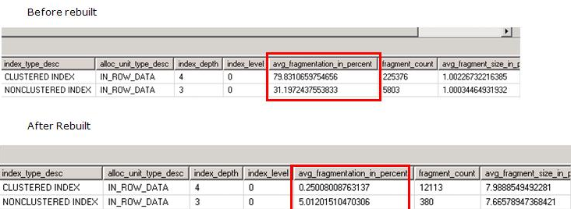

**Setting for Info Objects and Info Provider levels**

There are different level settings that can affect F4 behavior in BW query. Settings for Info Objects, Info Provider /for Navigational Attributes only/ and Web Template levels to improve the perofrmance of filter dialog box in queries

The F4 mode for a characteristic in the variable screen can be set on following levels

1. Info Object properties
2. Info provider specific properties /for Navigational Attributes only/

Level 2 setting will supersede level 1 setting. If Level 2 is not set, the system will use level 1 setting.

**Info Object properties –** You can set F4 mode in *Query Execution Filter Val. Selectn* in tab *Business Explorer* as follows

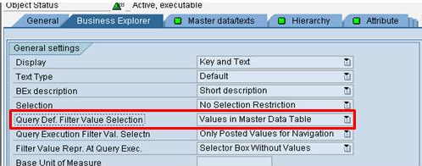

**Info provider specific properties**

In RSA1, edit the corresponding Info Provider, right click on the characteristic and set F4 mode in info provider specific property depending on the requirement

For Navigational Attributes the performance can be optimized in the following way

*F4 help for navigational attributes is handled differently from normal characteristics.*

The possible F4 modes for navigational attribute A__B /characteristic B is the navigational attribute of characteristic A/ are - M mode, D mode, Q mode and a special internal A mode /which can’t set directly in all property setting interface/.

1. **M** mode - all value in master data table for characteristic B.
2. **A** mode - all available B values in master data table for characteristic A.
3. **D** mode - all available B values posted in info provider via characteristic A /Technically this means the join of X-table of characteristic A with D-table of the info provider/.
4. **Q** mode - available B values in query result set for characteristic A. This mode is only possible in *Select Filter Value* in query result.

For the F4 help for a navigational attribute A__B, in web queries the system will use A mode to read F4 values by default. This means, that only characteristic B values available in characteristic A master data table will be displayed. This will perform a join between A master data table with B. *In case A and B have very big master data tables, the F4 performance may degrade. To avoid such a join, please set the M mode for characteristic B in RSD1.*